**AIM: Implementation of ID3**

**THEORY:**

ID3 stands for Iterative Dichotomiser 3 and is named such because the algorithm iteratively (repeatedly) dichotomizes(divides) features into two or more groups at each step.

Invented by Ross Quinlan, ID3 uses a top-down greedy approach to build a decision tree. In simple words, the top-down approach means that we start building the tree from the top and the greedy approach means that at each iteration we select the best feature at the present moment to create a node. Most generally ID3 is only used for classification problems with nominal features only.

1. **IMPORTING LIBRARIES:**

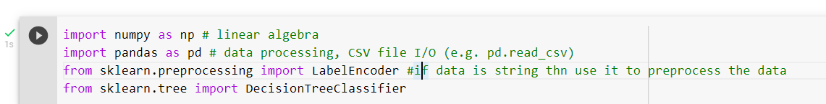

1. **READING DATASET:**

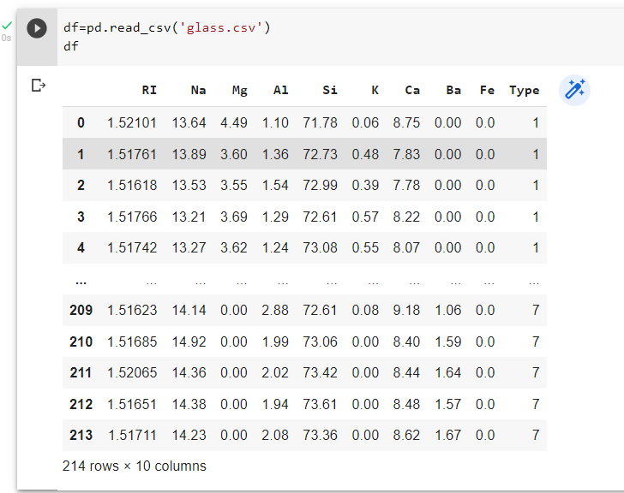

1. **EXTRACTING FEATURES:**





1. **MAKING MODEL:**



1. **SPLITTING DATASET INTO TRAINING , TESTING & PREDICTING VALUES:**

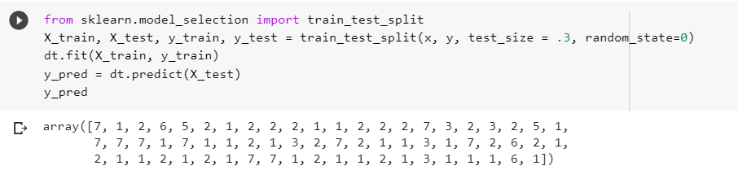

1. **CONFUSION MATRIX:**



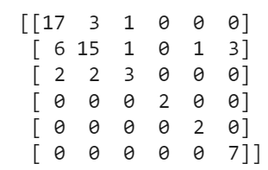

**CONCLUSION:**

From this practical, I have learned about implementation of ID3 algorithm in python.